**DESIGN FORGE**

**PROBLEM STATEMENTS**

**1. Mindful Watching Without Killing Engagement**

Redesign YouTube’s mobile viewing experience to discourage compulsive binge-watching—but in a way that doesn’t negatively affect engagement or retention. Your design should subtly influence user behavior through interface alone (no backend logic), preserving the dopamine-driven flow of content consumption.

Focus Areas:

* Micro-interactions that promote break-taking
* Visual rhythm cues tied to watch patterns
* Non-intrusive session/time reminders
* Subconscious nudges baked into layout

**2. Device-Handoff UI with No Friction & No Confusion**

Design an invisible but discoverable interface that allows users to instantly pick up a video where they left off, on any other device (TV, laptop, mobile), without friction or manual syncing.

Focus Areas:

* Spatial consistency across devices
* Passive vs. active state transitions
* Visual continuity (position, progress, etc.)
* Temporary “handoff” indicators that auto-dismiss

**3. AI-Organized Comment Layer With Real-Time Video Context**

Redesign YouTube’s comment section to dynamically reorganize in real-time based on what the user is seeing in the video—keeping it simple, readable, and relevant.

Focus Areas:

* Live-linked comments UI (floating? scroll-sync?)
* Visual anchors for context without crowding
* Readability and accessibility on small screens
* Timestamp filters that feel native

**PROBLEM STATEMENT I CHOSE:**

**1. Mindful Watching Without Killing Engagement**

Redesign YouTube’s mobile viewing experience to discourage compulsive binge-watching—but in a way that doesn’t negatively affect engagement or retention. Your design should subtly influence user behavior through interface alone (no backend logic), preserving the dopamine-driven flow of content consumption.

Focus Areas:

* Micro-interactions that promote break-taking
* Visual rhythm cues tied to watch patterns
* Non-intrusive session/time reminders

Subconscious nudges baked into layout.

**REASON FOR MY CHOICE:**

I chose problem statement 1 “Mindful Watching Without Killing Engagement”, because binge-watching on platforms like YouTube has become an increasingly common habit, especially among younger audiences. While the algorithm-driven content delivery is highly effective at keeping users engaged, it often leads to unintentional overconsumption and reduced productivity or even screen fatigue.

I wanted to explore how **UX/UI design alone**—without altering backend algorithms—could subtly guide users toward **healthier viewing habits** without compromising the **seamless and addictive experience** they enjoy. By focusing on micro-interactions, visual cues, and subconscious nudges, my goal was to strike a balance between **mindful watching** and **user satisfaction**.

This challenge felt particularly relevant and impactful, as it blends **design thinking, psychology, and ethics**, encouraging us as designers to create digital environments that respect user well-being while supporting product goals.

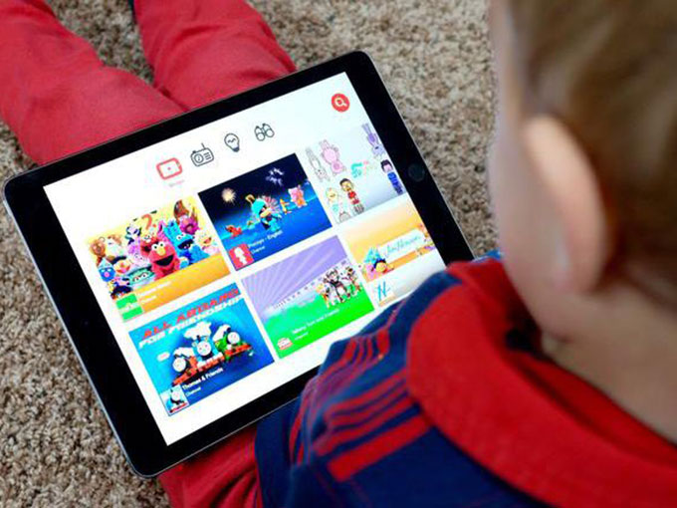

**DESCRIPTION OF FIGMA DESIGN – MINDFUL WATCHING WITHOUT KILLING ENGAGEMENT**

This Figma design proposes a redesigned YouTube mobile experience aimed at reducing compulsive binge-watching behavior through subtle, UI-driven nudges—without compromising user engagement or retention.

**Frame Breakdown:**

* **Frame 1:** The user starts from the mobile home screen, launching the YouTube app at 11:17 AM.
* **Frame 2:** A minimalist YouTube loading screen creates a small pause that encourages intention before entering the app.
* **Frame 3:** The default YouTube home screen appears, showcasing familiar and engaging content. This maintains the dopamine-driven flow users expect.
* **Frames 4–8:** As the user continues watching videos, the interface begins to introduce subtle visual cues:
  + A **faint red overlay line** slowly darkens with each video watched, signaling time passage subconsciously.
  + The content cards begin to **slightly desaturate** or shift visually, prompting subtle mental breaks without fully interrupting.
  + A **thin timer progress indicator** appears under each video card, suggesting how long a user has been engaged.
* **Frame 9:** After prolonged usage, a **gentle reminder** in the form of a shaded overlay with soft text (not a popup) suggests a break or a stretch, while still allowing users to continue watching seamlessly.

**Key Design Tactics:**

* **Micro-interactions:** Timed visual shifts and slight animations nudge users to self-regulate without feeling forced.
* **Visual Rhythm Cues:** The red overlay lines and progressive UI fading act as rhythm signals to reflect prolonged sessions.
* **Non-intrusive Reminders:** The final frame’s overlay reminder is empathetic, not disruptive.
* **Subconscious Nudges:** Design relies solely on interface flow, not backend logic, to encourage mindful consumption.

This design preserves the continuous consumption pattern users love, while gently steering them toward healthier habits through interface design alone.

**DESIGN IMAGE:**

**Design**

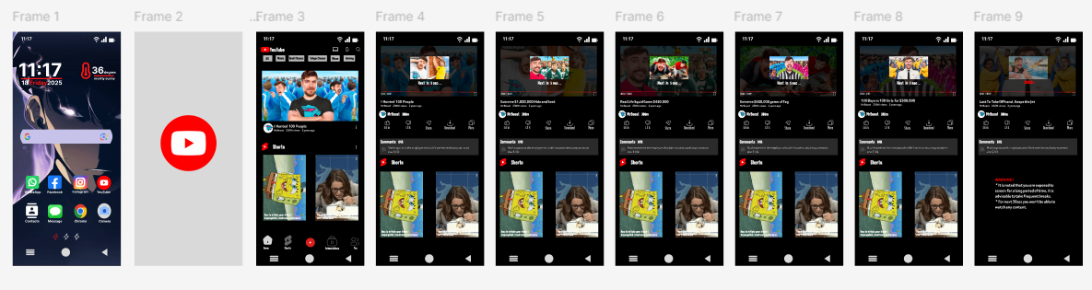

**Prototype**

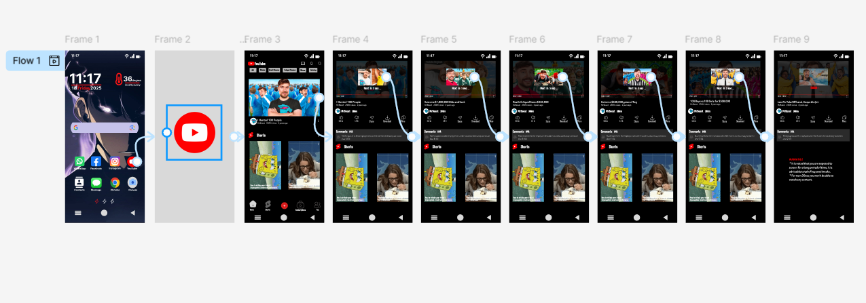

**Initial phase, Intermediate phase, and Final phase:**

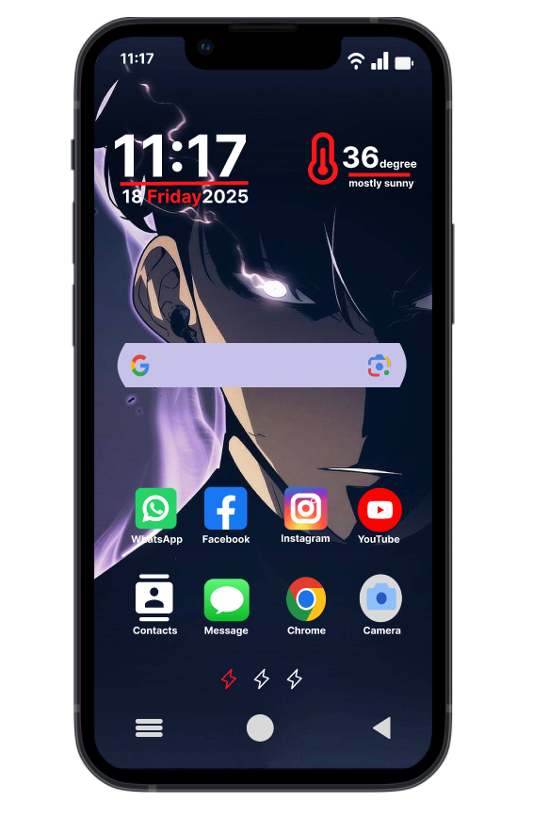 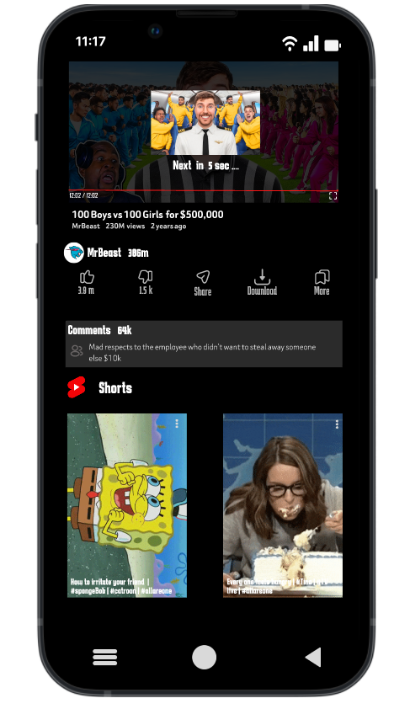 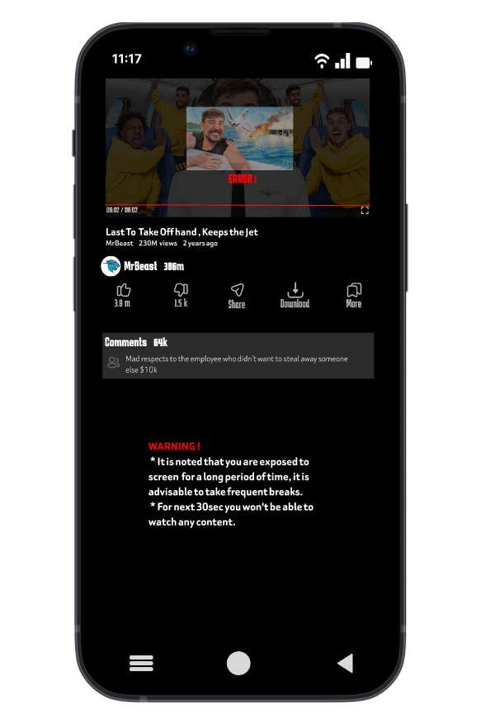

**Figma Link:**

**https://www.figma.com/proto/QSIcZi9Xmm7tipYVncfDNx/Topic-1?page-id=0%3A1&node-id=33-357&p=f&viewport=241%2C83%2C0.67&t=V6vqZf0Rzy19sYXt-1&scaling=scale-down&content-scaling=fixed&starting-point-node-id=5%3A5**